
Nagar Yuwak Shikshan Sanstha’s
Form No YI-02

Yeshwantrao Chavan College of Engineering
(An Autonomous Institution affiliated to Rashtrasant Tukadoji Maharaj Nagpur University)
Hingna Road, Wanadongri, Nagpur - 441 110
Ph.: 07104-237919, 234623, 329249, 329250 Fax: 07104-232376, Website: www.ycce.edu
Department of Computer Science and Engineering
Date: 27/04/2026

Undertaking by Student

This Semester Long Internship is a part of my B.Tech. VIIIth Semester degree course curriculum under which I will be evaluated. I have completely read the attached guidelines of Semester Long Internship. During the entire period, from Date to date
13/05/2026
31/01/2026
of Semester Long Internship, I, Vaishnavi Subhash Asare all strictly abide by the rules and regulations, safety guidelines, of Cognizant Technology Solutions, failing which my Internship shall be terminated with immediate effect. In addition to this, I will follow the COVID-19 norms, from the date of reporting at industry. Yeshwantrao Chavan College of Engineering Nagpur or Cognizant Technology Solutions will not be responsible case of mishap/eventualities happen.

I am aware that the Evaluation Report is to be submitted to Faculty Mentor / Guide with the consent of Industry persons/Trainers. This evaluation report along with TWO Internship Presentations carries total 100 marks which will be clubbed with ER of 2 credits in my SoE of 8th semester.


Name & Signature of Student:
Vaishnavi Subhash Asare
M. No:9022608117

Undertaking by Parent

I, being the Parent/Guardian of Vaishnavi Subhash Asare, do hereby undertake that my ward is going on Semester Long Internship to Cognizant Technology Solutions as a part his/her curriculum. I undertake that my daughter Vaishnavi Subhash Asare studying in B.Tech. VIIIth Semester shall follow the rules and guidelines of college as well as Industry.
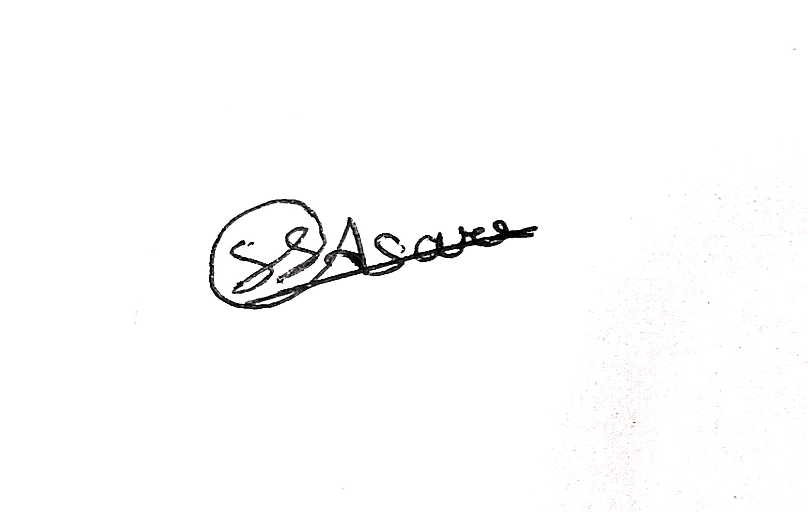

Name & Signature of Parent:
Subhash Asare
M. No: 8698405758

